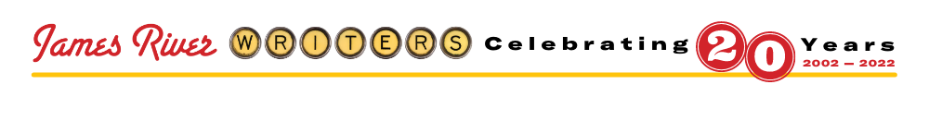

February 2022 WRITING SHOW | Using Fewer Words for Bigger Impact

Tuesday, February 22, 2022 | 6:00 pm – 8:30 pm | ONLINE via Zoom
James River Writers is proud to collaborate with the Virginia Screenwriters Forum to bring you this special Writing Show. Economy of words is essential for screenplays, stage plays, and poetry, and it can enhance the readability of other fiction and non-fiction works as well. This conversation brings panelists together who regularly choose fewer words for deeper impact—including writers from the screenwriting, microfiction, and poetry communities—to answer your questions about getting the most bang for your writing buck.

Speakers: Brenda Peynado, Franklin jin Rho, Ran Walker
Moderator: Terry Menefee Gau
SPEAKERS
Brenda Peynado (maribren@gmail.com)
Brenda Peynado's genre-bending short story collection, The Rock Eaters—featuring alien arrivals, angels falling from rooftops, virtual reality, and sorrows manifesting as tumorous stones—was listed as one of the New York Public Library's ten best books of 2021 and NPR's best books of 2021. Her stories have won an O. Henry Prize, a Pushcart Prize, Chicago Tribune's Nelson Algren Award, and inclusion in The Best American Science Fiction and Fantasy. She teaches creative writing at the University of Houston.

Website brendapeynado.com | Twitter @brendapeynado

Franklin jin Rho (franklinjinrho@gmail.com)
Currently a co-producer on an upcoming WB / Netflix series, Incarnate, Franklin was born and raised in Richmond, Virginia. Present projects in development include Han, an international corporate tech thriller, and The Beautiful South, a series set in Appalachia developed through the Rideback / MRC TV Incubator. A graduate of William and Mary and the American Film Institute, Franklin's writing credits include Pachinko, The Exorcist and Swamp Thing. For funsies, he mountain bikes, coaches Ultimate frisbee and soccer, and plays video games with his daughter.

Twitter @franklinrho

Ran Walker (ranwalker@icloud.com)
Ran Walker is the author of twenty-four books. He is the winner of the Indie Author Project’s 2019 Indie Author of the Year Award, the 2019 Black Caucus of the ALA Fiction Ebook Award, the 2018 Virginia Author Project Award for Adult Fiction, and the 2021 Blind Corner Afrofuturism Microfiction Award. He teaches creative writing at Hampton University and at Writer’s Digest University and lives with his wife and daughter in Virginia.

Website ranwalker.com | Twitter @ranwalker

MODERATOR

Terry Menefee Gau (tgau13@gmail.com)
Terry Menefee Gau is an accomplished actor & writer, as well as a non-profit professional for the past twenty years. She has a varied theatre and film resume, spanning over twenty-five years as an actor, producer, writer, and director. Terry is a proud member of the Virginia Screenwriters Forum and has several award-winning scripts under her belt. She also works at VPM as an events manager in Community Engagement. Terry received her M.Div. and MACE from Union Presbyterian Seminary, focusing in Narrative and Film Theology, and she has a B.S. in Mathematics from James Madison University. She loves the dichotomy of art and logic, spirit and reason.

Twitter @TerryGau

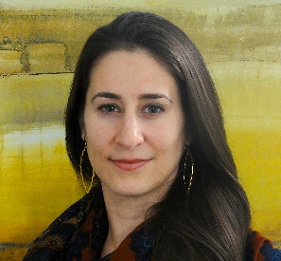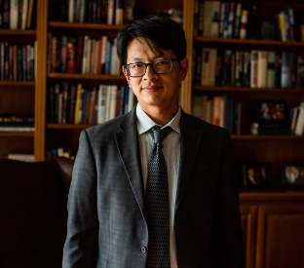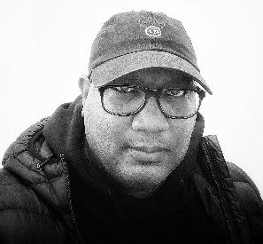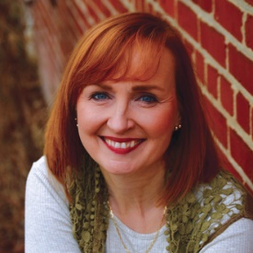
Left to right: Brenda Peynado, Franklin jin Rho, Ran Walker, and Terry Menefee Gau

ONLINE FORMAT
5:45 pm – Panelists/Moderator “meet” early to get ducks in a row prior to guests being admitted to Zoom session
6 – 8:30 pm Duration of Entire Program
6 – 6:45 pm | Social
Before the program begins, attendees may ask JRW staff questions and/or chat with other participants. This is optional for speakers. While the social period goes on, panelists may duck out and return in time for the panel discussion to begin, or stay and socialize with guests. It’s completely up to you! Kindly return by 6:40 pm, if you do decide to duck out.
6:45 - 7:30 pm | Panel Discussion Moderated panel discussion will begin promptly at 6:45 pm. JRW staff welcomes everyone, covers housekeeping items, and hands things over to Moderator.
7:30 - 7:40 pm | Intermission Use this time to grab a drink or take a restroom break. Participants their writing success stories via the Chat function, and JRW will share with participants after the break.
7:40 - 7:50 pm | JRW Shares Success Stories
7:50 - 8:30 pm | Q&A with Panel (questions submitted via chat function at any time during the presentation)

NOTES FOR PRESENTERS:
- JRW staff (either Katharine Herndon – Executive Director, or Brynn Markham – Director of Programs & Communications) will take care of all tech and help presenters keep track of time.
- The Writing Show Moderator will introduce themself, as well as the other speakers, and then begin the program. After the intermission and the JRW staff welcomes folks back and reads the Writing Successes, the Moderator will facilitate the Q&A by reading participant questions submitted via the Zoom chat function. JRW Staff will be there to help with this, as needed.
- JRW will include all presenters in the email to registrants the morning of the Writing Show that will include program details, including the link to join the Zoom meeting. Registration closes midnight, the day before the program.
- Please help us promote the Writing Show with the shared graphics, as well as by liking and sharing any social posts we may tag you in.
- Feel free to call or text Brynn Markham on her cell at 407.733.6971, should you have any difficulties the evening of the program.
- If, at any time, anyone gets dropped during the program, simply return to the email with the Zoom link and rejoin the meeting. Participants have become quite comfortable and forgiving with small technical difficulties as we all use these platforms more and more, so please don’t be alarmed. It happens to everyone at some point!

James River Writers is excited to have you as part of our next Writing Show!

